Action to Focus and Accelerate Cell-based Tolerance-inducing Therapies

Europe's Biggest Research Network on CTT

Dear colleagues,
It is our pleasure to announce Workshop on cell-based tolerance-inducing therapy that is going to be held in Belgrade, Serbia on May 11th, 2016. This workshop is an event organized by COST Action BM1305 - Action to Focus and Accelerate Cell-based Tolerance-inducing Therapies (A FACTT) in conjunction with the A FACTT MC/WG meeting at May 9,10th. Early carrier researchers are encouraged to apply for participation in the workshop. The application should include CV and a motivation letter and should be sent to e-mail: djordjem@ibiss.bg.ac.rs not later than March, 21st . There will be no fee for participation, but there is a limit to the number of participants.
Organizers
Dr Eva M MARTINEZ-CACERES
Chair of the Action
Dr Anja TEN BRINKE
Vice Chair of the Action

Local organizer
Dr Djordje MILJKOVIC
Institute for Biological Research “Sinisa Stankovic”
University of Belgrade

Workshop on cell-based tolerance-inducing therapy:
9.00- 9.30 Djordje Miljkovic
INTRODUCTION TO CELL-BASED TOLERANCE-INDUCING THERAPY
9.30- 10.00 Eva Martinez-Caceres
TOLEROGENIC DENDRITIC CELLS-VITD3 LOADED WITH MYELIN PEPTIDES AS A TREATMENT FOR MS PATIENTS.
10.00- 10.30 Maria Cristina Cuturi
TOLEROGENIC DENDRITIC CELLS FROM ANIMAL MODELS TO A CLINICAL PROTOCOL
Break
11.00- 11.30 Giovanna Lombardi
CLINICAL GRADE MANUFACTURE OF REGULATORY T CELLS TO PROMOTE TRANSPLANTATION TOLERANCE: CHALLENGES AND ACHIEVEMENTS
11.30- 12.00 Piotr Trzonkowski
ATMP AS A CHALLENGE IN MANUFACTURING OF T REGULATORY CELLS
Lunch
13.00- 13.30 Thomas Giese
PRACTICAL APPROACHES IN POLYCHROMATIC FLOW CYTOMETRY
13.30- 14.00 Anja ten Brinke
ANTIGEN-SPECIFIC IMMUNOMONITORING
14.00 – 14.45 Phil Lord/Catharien Hilkens
DO YOU KNOW SOMETHING I DON'T? ORGANIZING AND SHARING OUR KNOWLEDGE OF IMMUNOLOGY
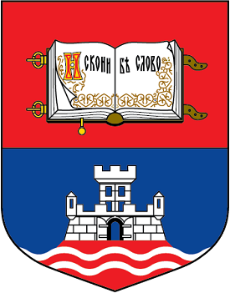
14.45- 16.00 OVERALL DISCUSSION

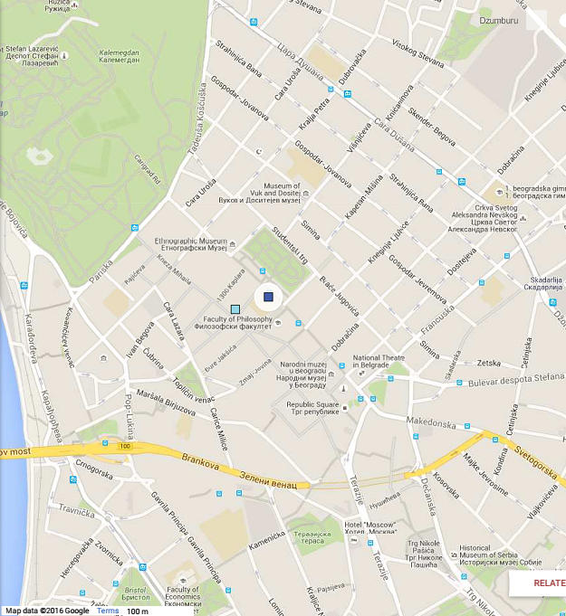
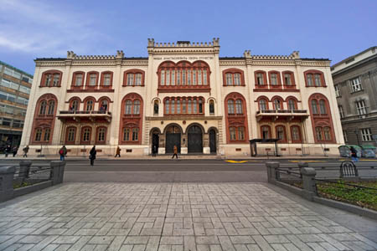
The workshop will be held at the University of Belgrade Rectorate

Studentski trg 1, Belgrade

CITY CENTER

